Steps That I followed:

1.On the part of case study here is some Git commands that I have practiced

Making a new branch

git branch <branch-name>

Switching to a branch

git checkout <branch-name>

Pushing the branch to Git

git push origin <branch-name>

For commit code to branch

git commit -m “[ Type in the commit message]”

To Merge from another branch

git merge [branch name]

git init

git add README.md

git commit -m "first commit"

git branch -M main

git remote add origin https://github.com/Anand-ramcharan/Armtemplates.git

git push -u origin main

Git commands That I used for push code files in Azure dev repo

Az login

Git init

git remote add origin https://anand846276@dev.azure.com/anand846276/Devopssample/_git/Devopssample

git push -u origin –all

2.As part of case study that we need to create all services in one resource group I have created Resource group in Azure poratal For that below command I have used

az group create --location westus --name MyResourceGroup

3. I have created Arm templates in VS code for storage account creation and Vnet and subnet creation and Azure Kubernetes service as well. Along with this I have created one ACR by using below command

* az acr create --resource-group myResourceGroup --name AksAcr6276 --sku Basic

And the Templates that which I have created in Vs code I have deployed them with below commands

IN the below screen shot in azure poratl I have one resource group under the resource I have AKS,VNET,ACR services

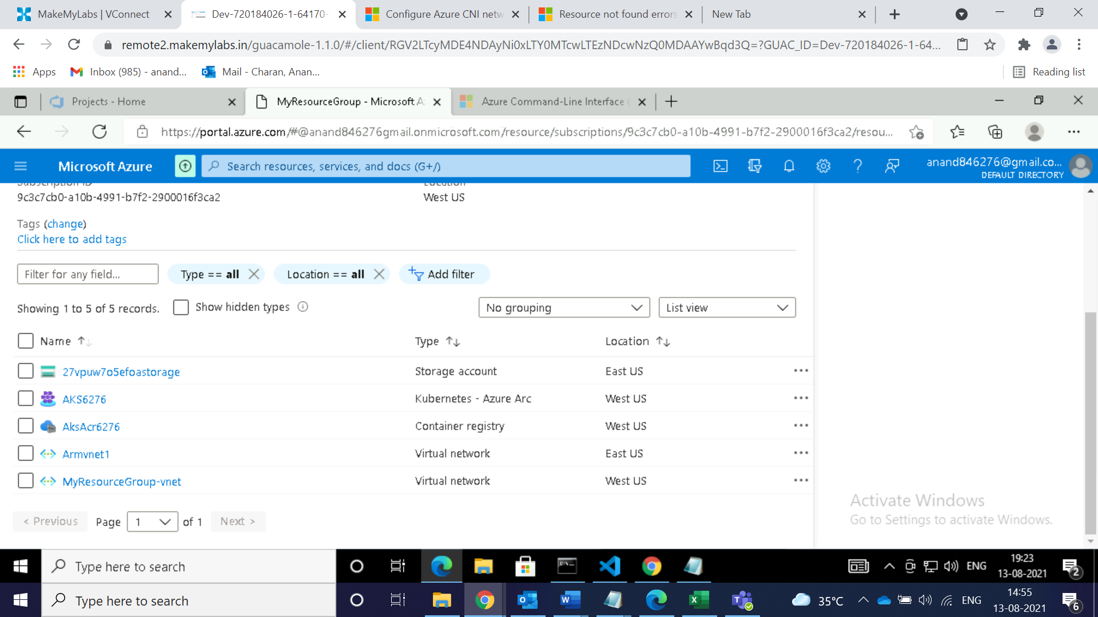

* az deployment group create --resource-group MyResourceGroup --template-file C:\Users\User\Desktop\Kubecluster\Armdepoloy.json --parameters C:\Users\User\Desktop\Kubecluster\Armparemter.json
* az deployment group create --resource-group MyResourceGroup --template-file C:\Users\User\Desktop\Kubecluster\AZKtemplate.json --parameters C:\Users\User\Desktop\Kubecluster\AZKparameter.json

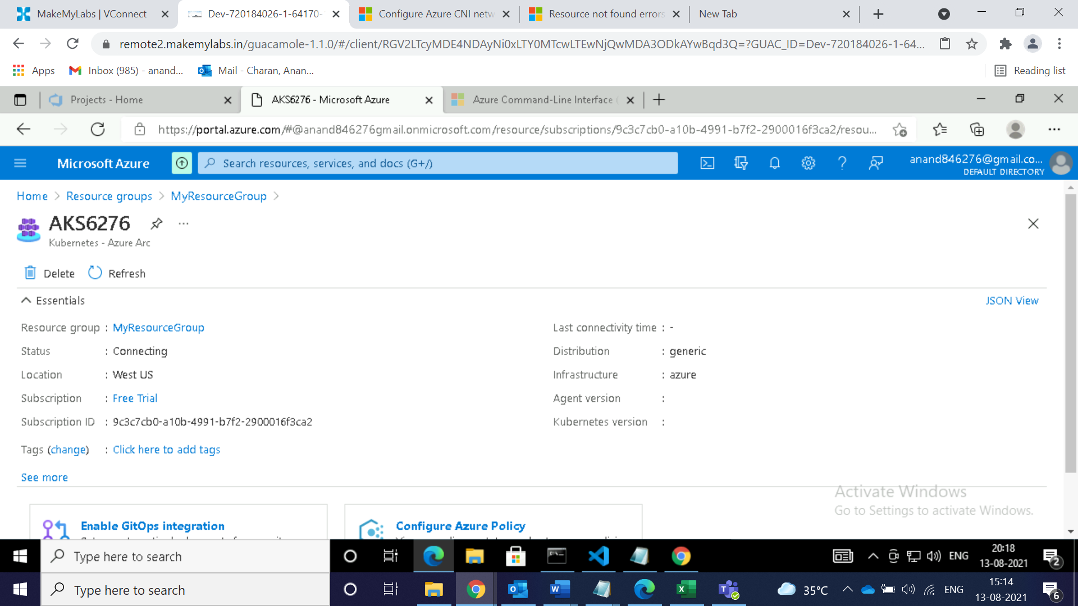

* az deployment group create --resource-group MyResourceGroup --template-file C:\Users\User\Desktop\Kubecluster\vnetarmtemplate.json --parameters C:\Users\User\Desktop\Kubecluster\vnetarmparameter.json

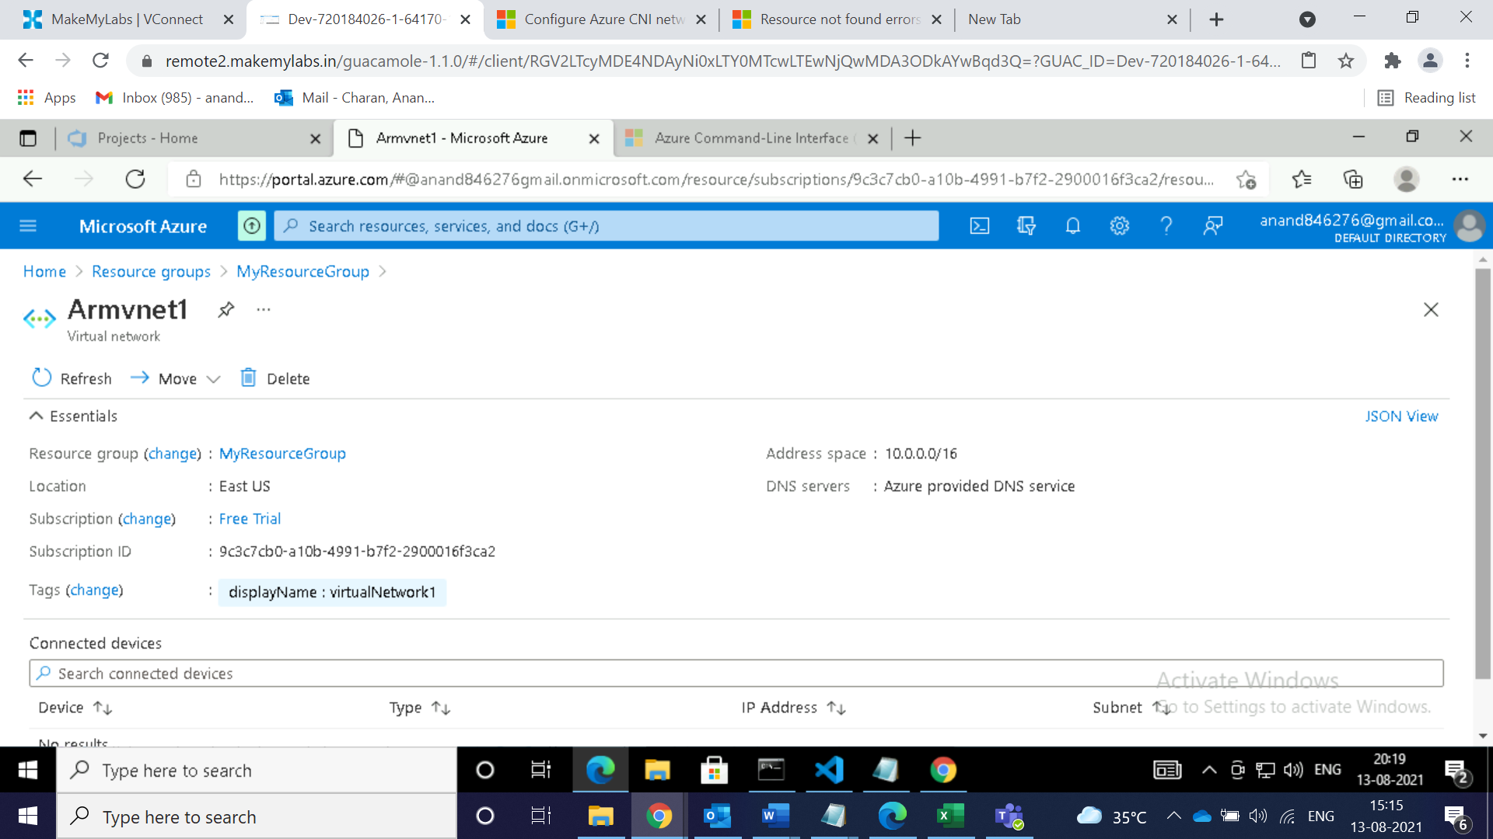

There are two levels of deployments subscripton level and Resource group level I have deployed all my services by referencing below commnds

for resource group

* az deployment group create --resource-group <resource-group-name> --template-file <path-to-template>

for subscription level

* az deployment sub create --location <location> --template-file <path-to-template>

4.By using below commnds I have pushed docker image to Azure container registery

* az acr create --resource-group myResourceGroup \--name AksAcr6276 --sku Basic
* az acr login --name AksAcr6276
* docker tag mcr.microsoft.com/hello-world AksAcr6276.azurecr.io/hello-world:v1
* docker push AksAcr6276.azurecr.io/hello-world:v1
* az acr repository list --name AksAcr6276 --output table
* docker run AksAcr6276.azurecr.io/hello-world:v1

For attaching AKS with ACR I have run a below commands I used

az acr create --resource-group myResourceGroup --name AksAcr6276 --sku Basic

az aks create -g AKS6276 -n AksRGS2 --location eastus --attach-acr AksAcr6276 --generate-ssh-keys

az connectedk8s connect --name MyResourceGroup --resource-group AKS6276az aks update -n Aks6276 -g MyResourceGroup --attach-acr AksAcr6276

I have Pushed the code into Azure Devops and created a pipeline and run Yaml file

